EART26201 | Principles of Geochemistry

Question 1
The oceanic crust is mostly composed of gabbro that contains crystals of plagioclase, clinopyroxene and olivine. The behaviour of the oceanic crust can thus be approximated using a phase diagram in the anorthite-diopside system, where anorthite (An) is Ca-rich plagioclase and diopside (Di) is Mg-rich clinopyroxene. Compositions are summarised in terms of the proportion of Di (X_{Di}).
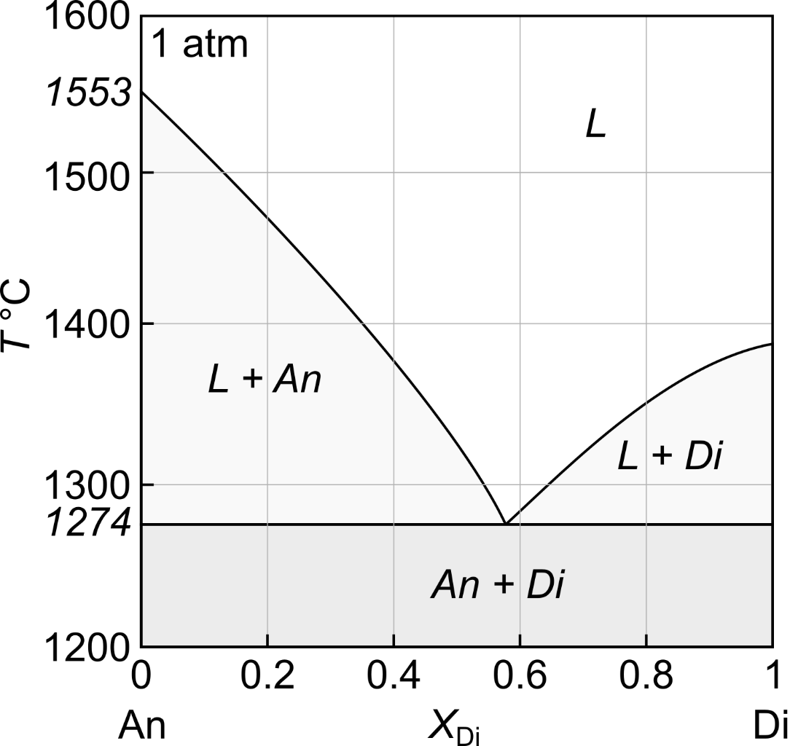
- With reference to the Gibbs phase rule ($f = c - Φ + 1$) and the An-Di phase diagram, explain what is meant by a divarient field, a univariant curve and an invariant point. [20%]
A divarient field is a region of a phase diagram with two degrees of freedom (f=2). This means that two intensive variable can be changed independently without altering the system state. The L, L+An, L+Di and An+Di fields on the An-Di phase diagram are divarient fields (c=2, phi=1) where both T and X can be changed independently without changing the system state.
A univariant curve is a reaction on a phase diagram with one degree of freedom (f=1). This means that only one intensive variable can be changed independently without altering the system state. The L→An and L→Di curves on the An-Di phase diagram are univariant curves (c=2, phi=2) where T and X cannot be changed independently without changing system.
An invariant point is a reaction on a phase diagram with no degrees of freedom (f=0). This means than no intensive variables can be changed without altering the system state. The L→An+Di eutectic on the phase diagram is an invariant point (c=2, phi=3) where neither T nor X can be changed without changing the system state.
- Gabbros from the oceanic crust sometimes melt when hot basalts are intruded from the mantle below. With reference to the An-Di phase diagram, describe what happens when a gabbro with a composition of X_{Di} = 0.3 undergoes equilibrium melting during heating from 1200 to 1600 °C. Discuss what would differ if the gabbro underwent fractional melting instead of equilibrium melting. [40%]
At 1200°C the solid gabbro contains 70%An and 30%Di. Once it is heated to 1274°C the, the first melt forms at the eutectic and as a composition of X_{Di}~0.57. Melting continues at 1274°C until Di is exhausted. Once solid Di left has been exhausted, heating continues and solid An continues to melt. The liquid composition evolves along the L→An curve until the composition of the liquid is the same as the composition of the system, X_{Di} = 0.3, at which point the final solid melts at ~1420°C. The system will then remain fully liquid as heating continues to 1600°C.
Liquids are immediately removed from the system during fractional melting, such that the composition of the system tracks the composition of the remaining solid. Thus, once Di has been exhausted by eutectic melting at 1274°C, the composition of the system will be pure An. In contrast with equilibrium melting, no further melting will therefore occur until the system is heated to the melting point of An at 1553°C at which point the last An melts.

- Trace elements are commonly used to understand geological processes like melting and crystallisation. Real oceanic gabbros contain crystals of plagioclase, clinopyroxene and olivine. Using the phase proportions and solid-liquid partition coefficients below, calculate the bulk partition coefficients for Ce and Ni in oceanic gabbros (${\overline{D}}_{Ce}$ and ${\overline{D}}_{Ni}$) and comment on their partitioning behaviours. [20%]
Solid phases | Phase proportions | $$D_{Ce}$$ | $$D_{Ni}$$
Plagioclase | 0.65 | 0.2 | 0.1
Clinopyroxene | 0.25 | 0.01 | 1
Olivine | 0.10 | 0.001 | 10

$${\overline{D}}_{Ce}=0.65×0.2+0.25×0.01+0.1×0.001=0.1326$$
$${\overline{D}}_{Ni}=0.65×0.1+0.25×1+0.1×10=1.315$$
Ce is incompatible during melting of the oceanic crust (partitions into the liquid) while Ni is compatible (partitions into the bulk solid).
- Using these bulk partition coefficients and the equilibrium melting equation below, determine the composition of melts produced by 40% melting of an oceanic gabbro containing 5 µg/g Ce and 300 µg/g Ni. Comment on which phases will contain the greatest concentrations of Ce and Ni after this melting. [20%]
$$\frac{C_{liquid}}{C_{solid}^{0}}=\frac{1}{\left({\overline{D}}_{i}+F\left(1-{\overline{D}}_{i}\right)\right)}$$
$C_{solid}^{0}=5$and $300$ for Ce and Ni, respectively. $F=0.4$.
For Ce: $C_{liquid}= \frac{5}{\left(0.1326+0.4\left(1-0.1326\right)\right)}=10.426 μg/g$
For Ni: $C_{liquid}= \frac{300}{\left(1.315+0.4\left(1-1.315\right)\right)}=252.3 μg/g$
Liquid contains the greatest concentration of Ce:$10.426 μg/g$
Olivine contains the greatest concentration of Ni: $252.3 ×10=2523 μg/g$

Question 2
A stream containing dissolved manganese (Mn) has an Eh value of +1.2 volts. The half reaction Mn⁺ = Mn²⁺ + e⁻ has an E₀ of +1.3 volts.

- Write a balanced redox reaction between MnO and Fe(OH)₃, and show each step in the balancing process. (50%)
- Calculate, using the Nernst, equation, the ratio of Mn²⁺ to Mn⁺ in the stream (50%).

(a) Fe²⁺ ⇋ Fe³⁺ + e⁻ (oxidation) and Mn²⁺ + e⁻ ⇋ Mn⁺ (reduction)
Fe²⁺ + Mn²⁺ ⇋ Mn⁺ + Fe³⁺
- Most reactions occur in water, for neutral or acid solutions (H⁺)
- The half reactions are written as:
Oxidation Fe²⁺ + 3H₂O ⇋ Fe(OH)₃ + 3H⁺ + e⁻
Reduction MnO + 2H⁺ + e⁻ ⇋ Mn⁺ + H₂O
- Combining:
Fe²⁺ + MnO + 3H₂O + 2H⁺ + e⁻ ⇋ Fe(OH)₃ + 3H⁺ + e⁻ + Mn⁺ + H₂O
Gives Fe²⁺ + MnO + 2H₂O ⇋ Fe(OH)₃ + H⁺ + Mn⁺
- Balance the atoms apart from oxygen and hydrogen.
- Balance the oxygens by adding water molecules.
- Balance the hydrogens by adding hydrogen ions.
- Balance the charges by adding electrons.
(b) The measured Eh of the stream is less oxidizing than the half-reaction, so we would expect most Mn to be in the form Mn+. The Nernst equation allows us to quantify this:
pE = pE0 – log[red]/[oxid]
pe = 16.9Eh
pE = 16.9 x 1.2 = 20.28
pE0 = 16.9 x 1.3 = 21.97
20.28 = 21.97 - log([Mn+]/[Mn2+])
-1.69 = - log([Mn+]/[Mn2+])
[Mn+]/[Mn2+] = 10^1.69 = 48.98 therefore 1/48.98= Mn2+/Mn+ = 0.02

